- We think overshoots for services inflation and private sector regular pay growth have extinguished any faint hopes that the Bank of England will cut interest rates in May. However, we expect the Monetary Policy Committee to reiterate that rate cuts are coming soon.
- The MPC is likely to cut its inflation forecast for H2 2024 – its February projection was 0.6ppts higher than our current forecast. But the timing of the first rate cut is likely to be heavily influenced by how the data measures up to the Bank of England's updated forecasts for services inflation and private sector regular pay growth. The April data remains key.
- The MPC's longer-term inflation profile should also be lowered because the forecasts will be based on a market rates curve that's on average 70bps higher than the February version over the next three years. In February, the MPC gave a clear indication it thought markets were too dovish. It could now deliver the opposite message with a sub-2% inflation forecast at the end of the forecast horizon.
- Internal members have tended to vote as a bloc of late, but recent speeches suggest these five members are less united than before. Reconciling the broad range of views across the committee presents a major communications challenge for the BoE.
At the start of this year, the Monetary Policy Committee's May meeting had looked likely to be pivotal, with a good chance of the first interest rate cut of this cycle being implemented. But enduring evidence of inflation persistence and the increasingly hawkish mood in financial markets steadily reduced the chances of a May rate cut. The data published in mid-April for services inflation and private sector regular pay growth has likely extinguished any remaining hopes of a move in May. Though both measures have continued to fall, progress has been slightly slower than the MPC anticipated, and they are currently running marginally higher than the forecasts published in February's Monetary Policy Report (Chart 1).

Chart 1: Services inflation and pay growth are running slightly above the BoE's previous forecast
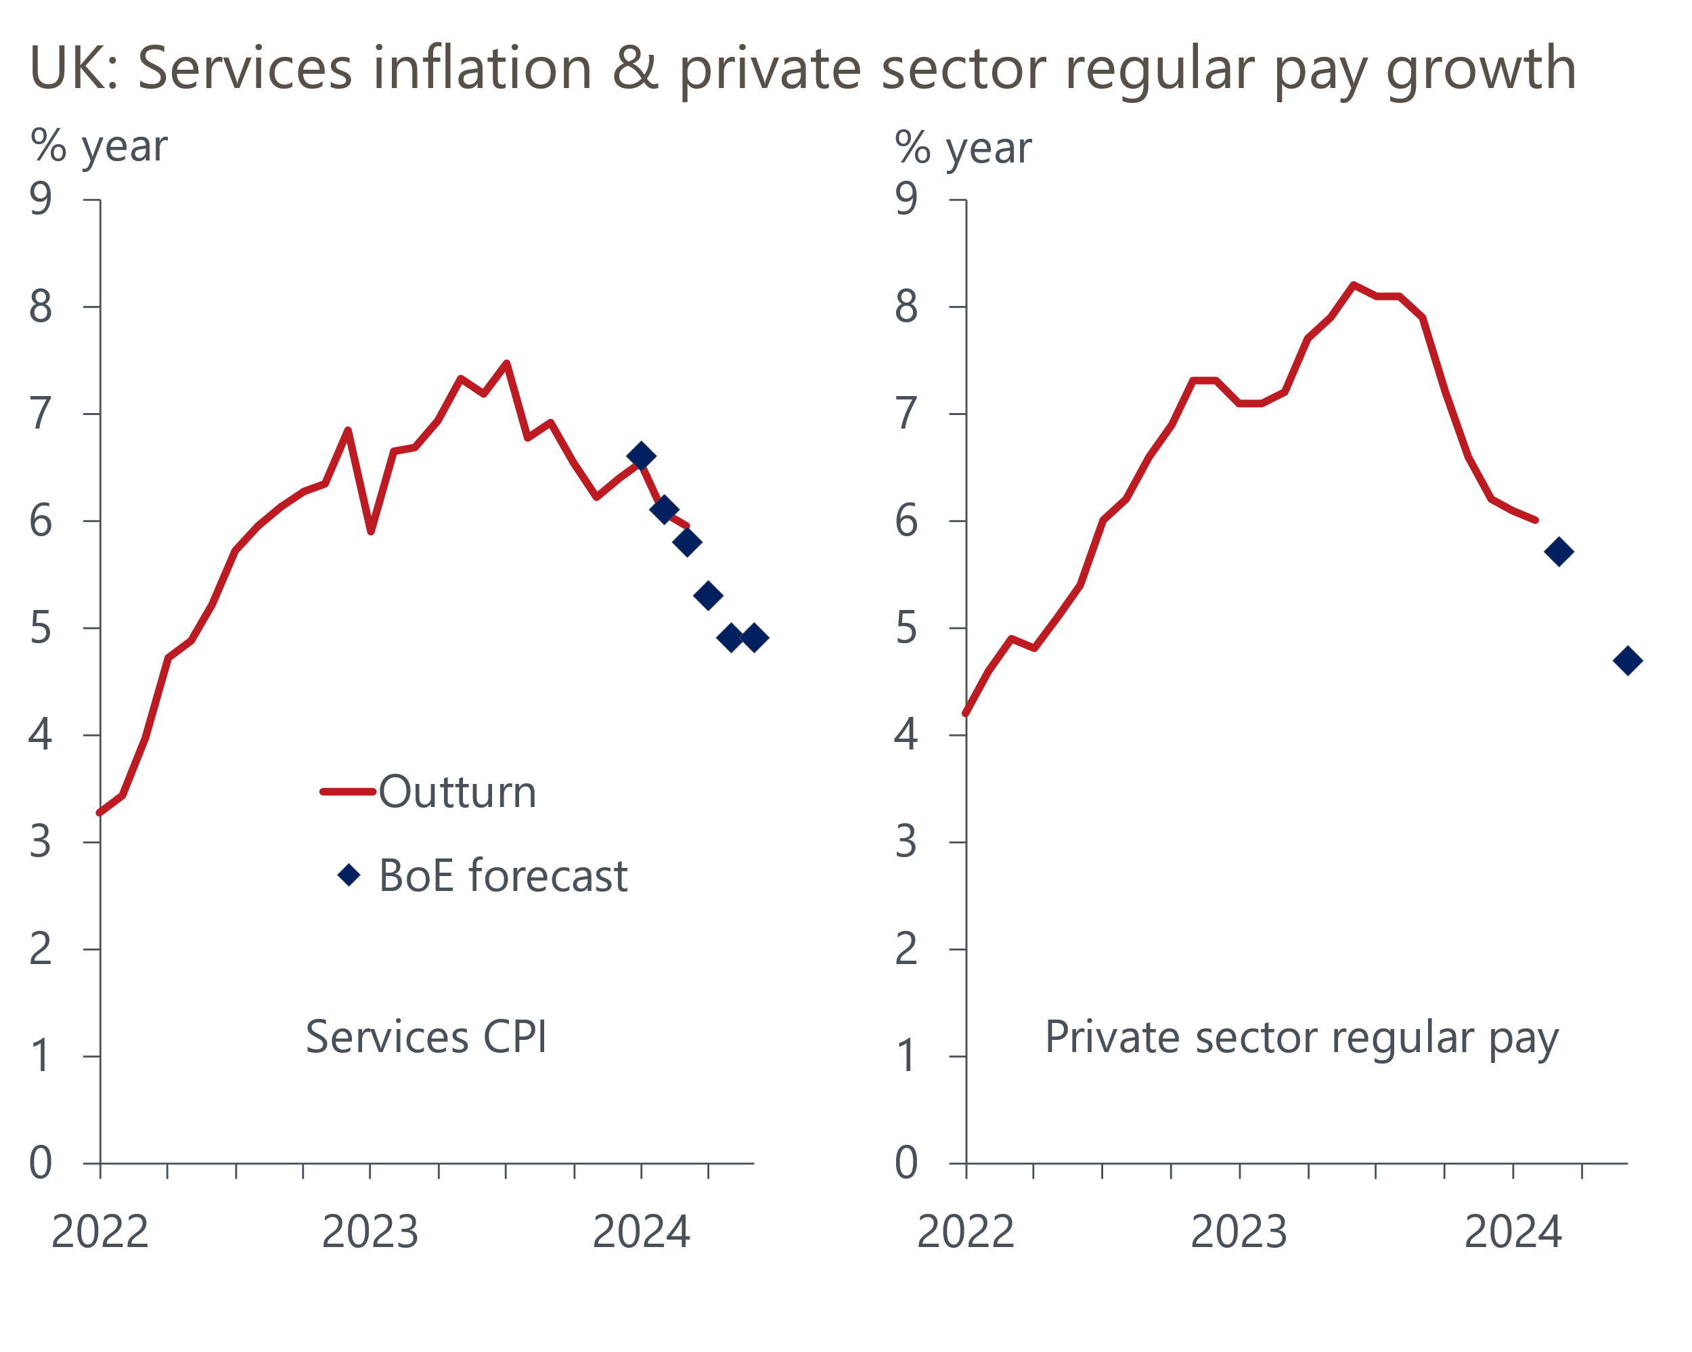
Sources: Haver Analytics, Bank of England Monetary Policy Report

The MPC's messaging has become more dovish in the early months of this year, with the current mantra being that it's a case of "when" not "if" interest rates are cut. This message is likely to be reiterated in the press conference that follows May's policy announcement. But the minutes of the March meeting reported a wide range of views on the timing and pace of rate cuts, and comments from committee members over the past month have suggested that even the previously solid bloc of internal members are divided (recent comments by MPC members are summarised in Table 1). Reconciling these divergent views into one message will present a major communications challenge for the Bank of England.

Markets expect rates to remain higher for longer
An added complication is that the May meeting follows significant movements in market pricing. After the March meeting, markets priced just short of three 25bps rate cuts before the end of this year. But at the time of writing, only one 25bps cut is fully priced, with just over a 50% chance of a second cut.
The MPC will present its updated forecasts at the May meeting, and the movement in market pricing since the previous set of projections were produced has been even greater. Market expectations for Bank Rate are now 63bps higher than before the February MPR for the end of 2024 and 88bps higher for end-2025 (Chart 2). All else equal, these changes imply some sizeable revisions to the MPC's forecasts.
Chart 2: The new market curve will be on average 70bps higher than February's version over three years
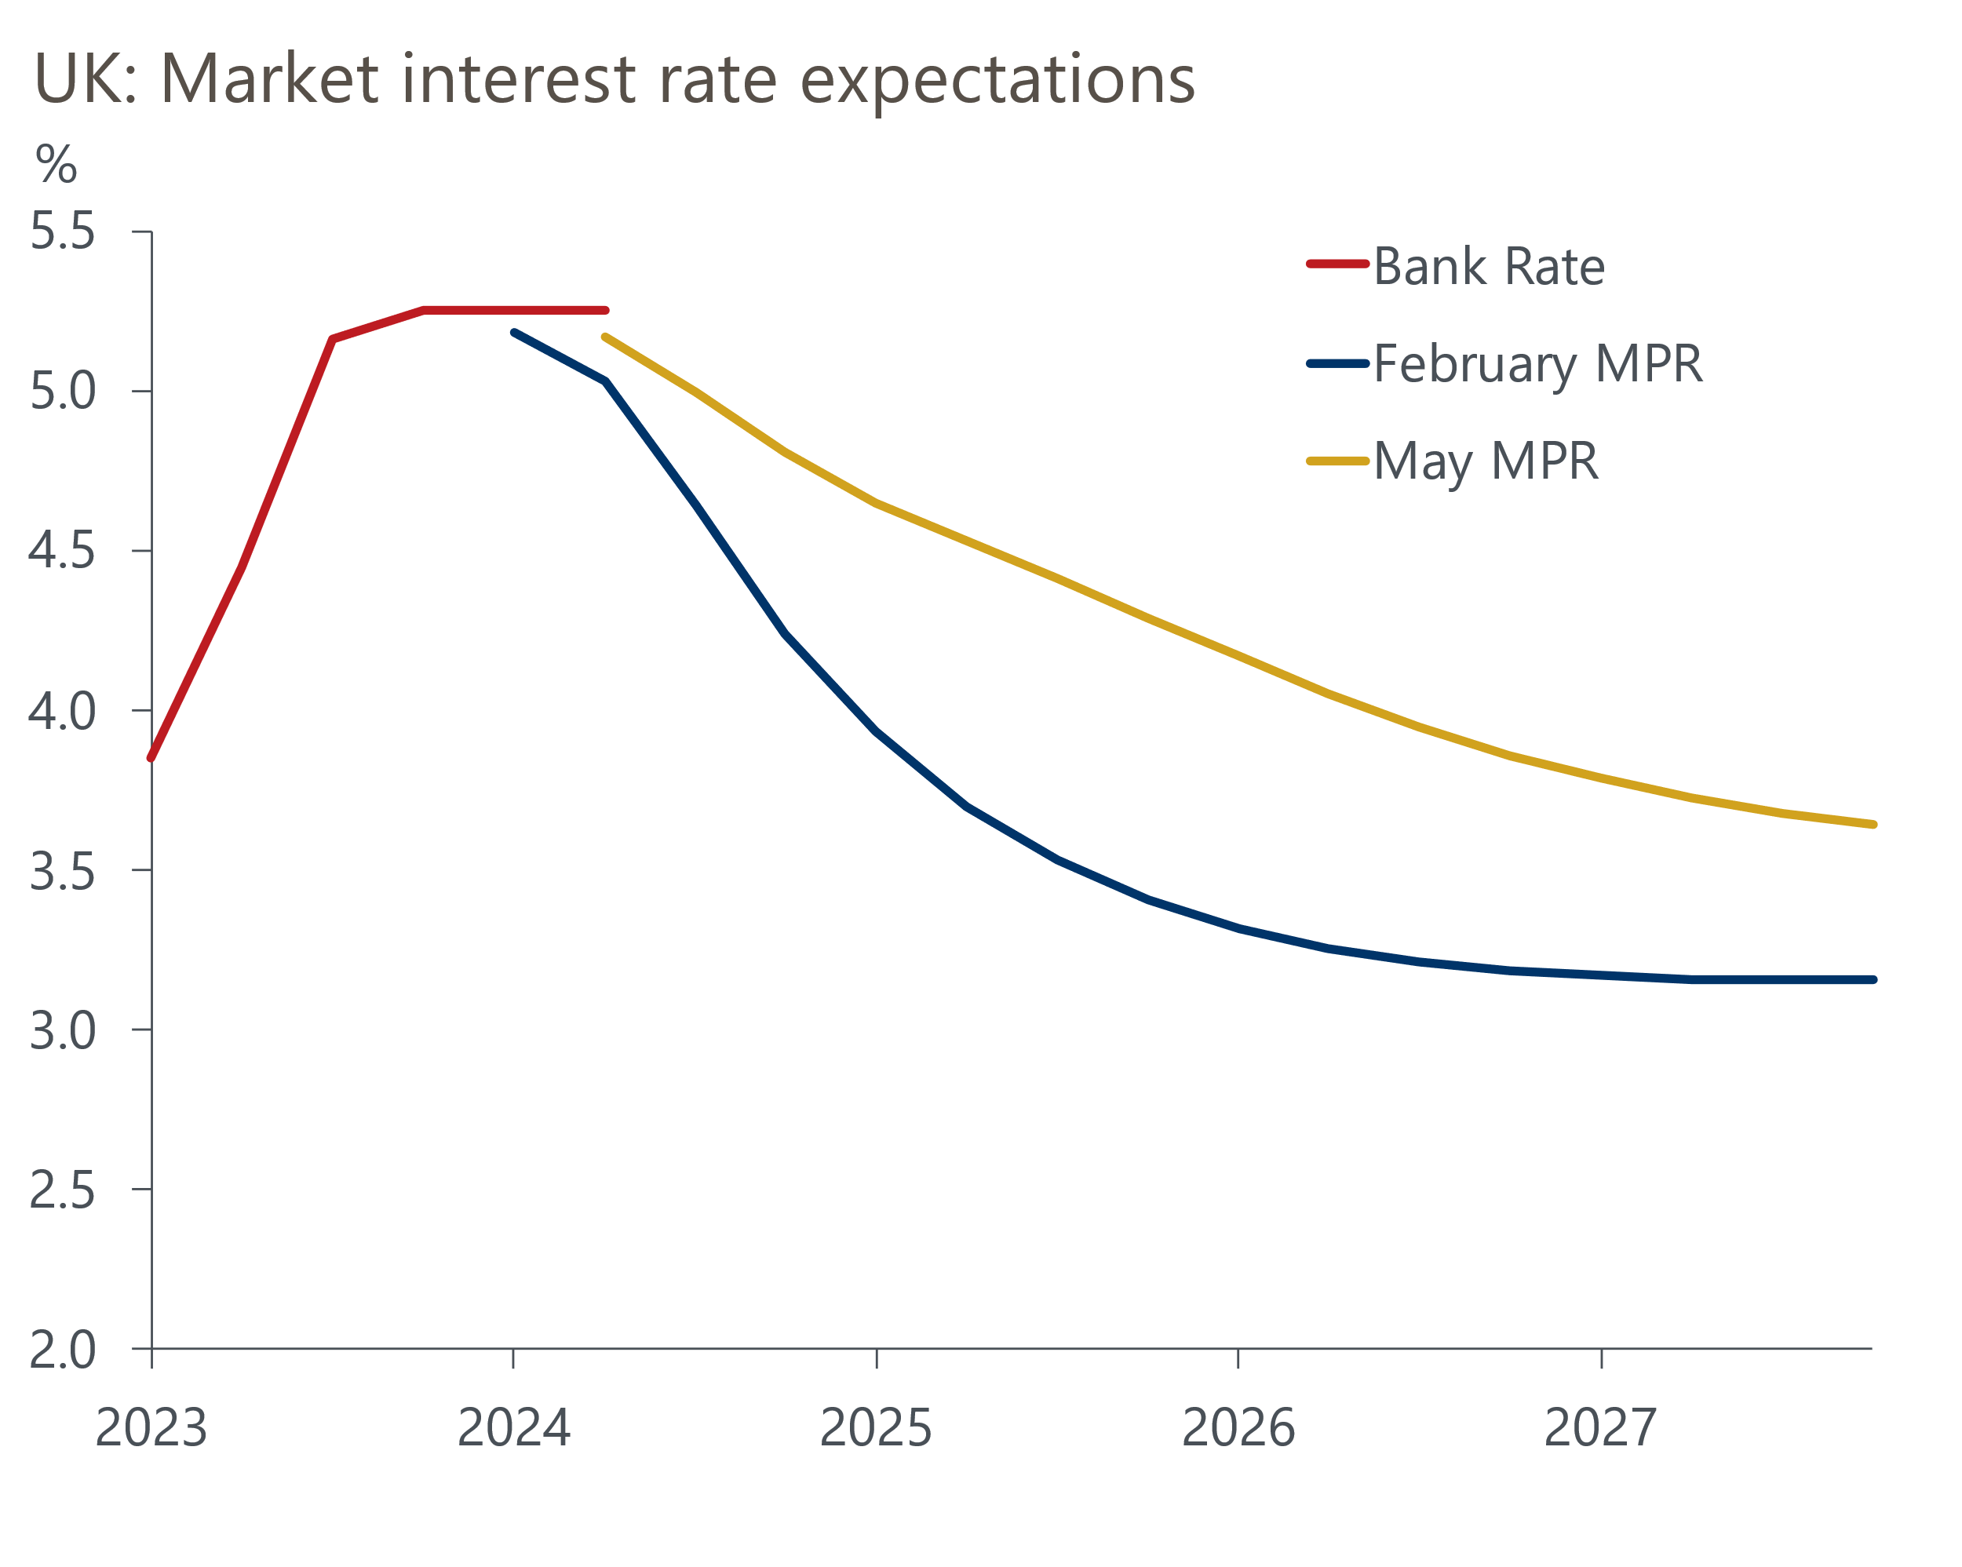
Source: Haver Analytics
In February, the MPC published a forecast where inflation was slightly above 2% at the two-year horizon, thus signalling that policy was unlikely to be loosened as aggressively as markets anticipated. This, plus the modest overshoots for pay and inflation, are consistent with a rise in market expectations for Bank Rate. But the scale of the increase since February looks out-of-keeping with these developments. The missing link appears to be the US, with markets seemingly concluding that with the Federal Reserve set to keep interest rates higher for longer, the BoE will end up following a similar course.
Various MPC members have sought to push back against this narrative. Most notably, Governor Andrew Bailey argued that "European inflation dynamics are somewhat different" with "more demand-led inflation in the US". But markets have largely ignored this message so far, so we'll be keen to see the extent to which the MPC tries to reiterate this point.
Indeed, we could see a repeat of the previous press conference in February, when Bailey was willing to be much more forthright in his comments than the language used in the minutes. Then, he made the point that policy would still be restrictive even after the MPC started to cut rates – this point was only formalised in the minutes of March's meeting.

The MPC is likely to cut its short- and long-term inflation forecasts
One way that the MPC is likely to reinforce its message is by cutting its inflation forecasts. The MPC's forecast for H2 2024 looks particularly curious, with inflation forecast to accelerate to 2.7% in Q4, 0.6ppts higher than both our projections and the consensus (Chart 3). The MPR only included detailed bottom-up inflation forecasts to June, so it's hard to unpick the rationale for the steep pickup in inflationary pressures. But the prospect of another chunky cut to the energy price cap in July is one factor arguing in favour of a lower inflation profile.
Chart 3: The MPC is likely to cut its short- and longer-term inflation forecasts
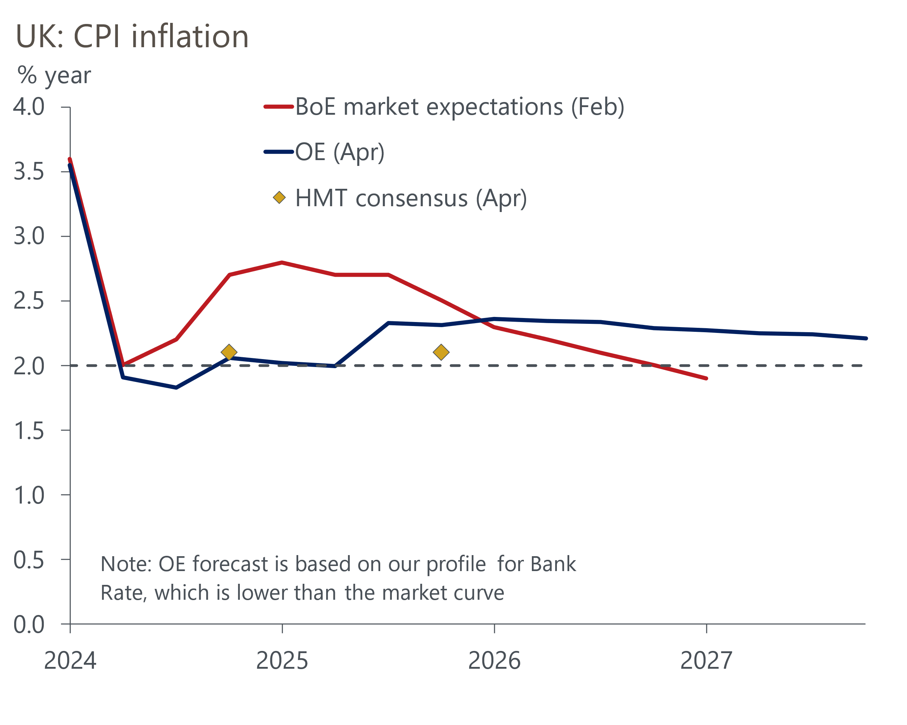
Sources: Oxford Economics, Bank of England, HMT
We also expect the MPC to cut its medium-term inflation profile. Based on market expectations, February's forecast showed a modest overshoot of the target two years out. With the market curve now on average 70bps higher across the forecast horizon, this implies lower forecasts for GDP growth and inflation. That said, the impact could be mitigated in the near term by stronger-than-expected activity at the start of this year and the modest loosening of fiscal policy announced in the Budget. Both factors will raise the near-term GDP forecast and reduce the degree of supply capacity that the BoE expects to develop.
We're not expecting the presentation of the MPC's forecasts to be much different to previous MPRs. The Bernanke Review was scathing of the BoE's forecasting approach and recommended retiring the trademark fan charts in favour of a scenario-based approach. But the BoE's response made clear that overhauling its approach would be a lengthy process. Furthermore, the bulk of the work comes under the responsibilities of the Deputy Governor for Monetary Policy, a role which will change hands in a couple of months' time when Clare Lombardelli replaces Ben Broadbent. It's unlikely we will see any substantive change until Lombardelli has had a chance to put her imprint on the role.

May's vote is likely to show only modest dissent against keeping rates on hold
March's meeting saw an 8-1 vote in favour of keeping Bank Rate at 5.25%. Jonathan Haskel and Catherine Mann stopped voting for rate hikes, while Swati Dhingra voted for a 25bps cut for the second successive meeting. We expect a similar vote in May. The only indication of any potential change of heart has been Dave Ramsden's recent speech, where he argued that the balance of risks to domestic inflation are now "tilted to the downside" relative to the BoE's February forecast. Ramsden could potentially join Dhingra in voting for a cut as a prelude to other internal members switching camps in the summer.
Still, having voted as a bloc in recent years, the five internal members appear less united than before. Several days after Ramsden's surprisingly dovish speech, Huw Pill struck a markedly more hawkish tone, suggesting the monetary policy outlook hadn't changed since his previous speech, when he had said that rate cuts were "some way off". There seems little prospect of any external member bar Dhingra voting for a cut in the near term. So, assuming Ramsden switches soon, the choice of when to cut will ultimately come down to the views of Bailey, Breedon, and Broadbent (or, beyond June, Lombardelli).
Bailey's recent comments have been fairly dovish, most notably his interview in the Financial Times after the March MPC announcement when he said "the fact that we have a curve that has cuts in it for the year as a whole is not unreasonable to me". But we've heard little from the other two. Ultimately, we expect their votes will be heavily influenced by how the data for private sector regular pay and services inflation evolves relative to the new forecasts that will be set out in the MPR. We continue to view the April data for both indicators as key. The pay data will show the impact of the NLW rise, while the inflation data will show the impact on core inflation of the annual increases for index-linked contracts and regulated prices.
The MPC will have both releases at its June meeting. On the pay front, our sentiment data (developed with Penta) offers cause for optimism, suggesting pay growth has slowed sharply, despite April's large increase in the national living wage. The data also suggests that labour market conditions are loosening. If this is reflected in official data, it will likely give the green light for rate cuts. But whether that's in June or August is a close call, and the extent to which market pricing responds could be key. In the hiking cycle, the MPC showed a reluctance to go against market expectations. So if markets remain hawkish, the MPC is likely to err on the side of caution and wait until August.
Table 1: Key comments by MPC members
Speaker and link | Date | Key takeaway
Pill | 23-Apr | The BoE's Chief Economist said the monetary policy outlook "has not changed substantially" since his March speech, when he had argued that rate cuts were "some way off".
Haskel | 23-Apr | Haskel, who only stopped voting for rate hikes in March, also argued that rate cuts should be "a long way off", warning that the "very tight" labour market is loosening only slowly.
Ramsden | 19-Apr | Deputy Governor Ramsden said he had "become more confident in the evidence that risks to persistence in domestic inflation pressures are receding". He argued that the balance of risks to domestic inflation are now "tilted to the downside" relative to the BoE's current forecast.
Bailey | 17-Apr | In comments on the fringes of the IMF meetings in Washington, the Governor argued that European inflation dynamics are "somewhat different" to the US, with more demand-led inflation in the US.
Greene | 11-Apr | In an op-ed in the Financial Times, Greene argued that markets should stop comparing the US and UK. But in contrast to the Governor, Greene argued that the risk of inflation persistence was greater in the UK than the US because of very weak potential output growth in the UK.
Mann | 26-Mar | Though Mann stopped voting for rate cuts at the last meeting, she argued that inflationary pressures from wages and services prices meant market expectations of three 25bps cuts in Bank Rate this year were "too many" and the same factors meant it was unlikely the BoE would move before the Fed.
Bailey | 22-Mar | In an interview with the Financial Times published the day after the March MPC announcement, the Governor said he was encouraged by evidence on inflation persistence and said that a market curve with cuts this year "is not unreasonable to me".
Source: Various

